
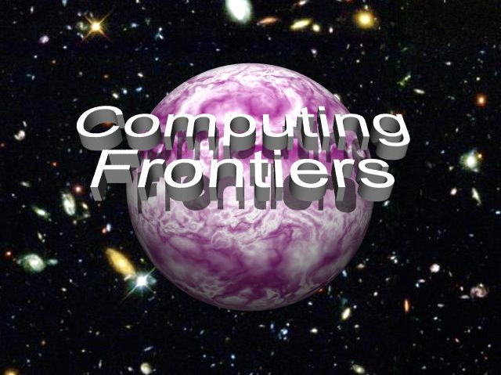

CALL FOR PAPERS
2011 ACM International Conference on Computing Frontiers

May 3 - 5, 2011, Ischia, Italy

Sponsored by ACM SIGMICRO



GENERAL CHAIR
Călin Caşcaval, Qualcomm, US

PROGRAM CO-CHAIRS
Viktor Prasanna, Univ. of Southern California, US
Pedro Trancoso, Univ. of Cyprus, CY

FINANCE and REGISTRATION CO-CHAIRS
Carsten Trinitis, TU München, DE, and
Univ. of Bedfordshire, UK
Hubertus Franke, IBM Research, US

SCHOLARSHIPS CHAIR
Nancy M. Amato, Texas A&M Univ., US

POSTERS CHAIR
Lucian Prodan, Univ. of Timisoara, RO

LOCAL ARRANGEMENTS CHAIR
Claudia Di Napoli, CNR, IT

PUBLICITY CO-CHAIRS
Sonia Lopez Alarcon, Rochester Inst. of Tech., US
Jaejin Lee, Seoul National Univ., KR

PUBLICATION CHAIR
Mohamed Zahran, New York Univ., US

WEB CHAIR
Alex Heinecke, TU München, DE

STEERING COMMITTEE
Monica Alderighi, INAF, IT
Nancy M. Amato, Texas A&M Univ., US
Steven Beaty, Metro State College Denver, US
Kemal Ebcioglu, Global Supercomputing, US
Georgi N. Gaydadjiev, TU Delft, NL
Hubertus Franke, IBM Research, US
Gearold Johnson, Colorado State Univ., US
Paul H J Kelly, Imperial College London, UK
Sally A. McKee, Chalmers Univ. of Tech., SE
Cecilia Metra, Univ. of Bologna, IT
Valentina Salapura, IBM Research, US
Giacomo Sechi, INAF, IT
Carsten Trinitis, TU München, DE, and
Univ. of Bedfordshire, UK
Alex Veidenbaum, Univ. of Southern California, US

Alex Veidenbaum, Univ. of Southern California, US



The increasing complexity and performance needs of current and future applications require novel and innovative approaches for design of various types of computing systems: embedded, mobile, high-performance, and more. Boundaries between state of the art and revolutionary innovation constitute the computing frontiers that must be pushed forward to provide the computational support required for the advancement of science and engineering. The Computing Frontiers conference focuses on a wide spectrum of advanced technologies and radically new solutions relevant to development of computer systems.
Authors are invited to submit full papers and poster papers on all areas of innovative computing systems that extend the current frontiers of computer science and engineering. Submissions are sought on innovations in theory, methodologies, technologies, and implementation of advanced computer systems. These may focus on computing paradigms, computational models, application paradigms, computer architecture, development environments, compilers, or operating environments. Papers are solicited in, but not limited to, the following areas:
- Applications, programming models and performance analysis of advanced architectures;
- Next-generation high performance computing and systems;
- Mobile computing: applications, wireless, platforms, systems, and interaction with clouds;
- Accelerators: many-core, GPU, custom, reconfigurable, embedded, and hybrid;
- Active libraries, domain-specific languages and generative techniques;
- Defect and variability-tolerant designs;
- Power and energy efficiency: architectures, compilers and algorithms;
- Virtualization and virtual machines;
- Cloud-, internet-scale, service-oriented and smart infrastructure computing;
- Compilers and operating systems: adaptive, run-time, and auto-tuning;
- System management and security;
- Quantum and nano-scale computing;
- Computational neuroscience, neuromorphic and biologically-inspired architectures;
- Novel frontiers in computational science and scientific data repositories;
- Computational aspects of intelligent systems and robotics;
- Reconfigurable, autonomic, organic, and self-organizing computation and systems;
- Interfaces and visualization for emerging applications and systems: displays, VR, and haptics.
Submissions must be made electronically in PDF format through the conference web site. Submitted papers must not exceed 10 double-column pages in standard ACM conference format, including figures, tables, and references. Delft University of Technology will present a best paper award dedicated to the memory of Stamatis Vassiliadis. As per ACM guidelines, at least one of the authors of accepted papers is required to register for the conference. Poster papers should not exceed 2 double-column pages in standard ACM conference format, including figures, tables, and references. Additional submission guidelines will be available on the conference web site.
Selected papers will be invited to be extended for a special issue of the Springer International Journal of Parallel Programming (IJPP).

Important Dates

Abstract Deadline  December 3, 2010 | Paper Submission Deadline  December 10, 2010 | Author Notification  February 14, 2011

For more information visit the conference web site at http://www.computingfrontiers.org

