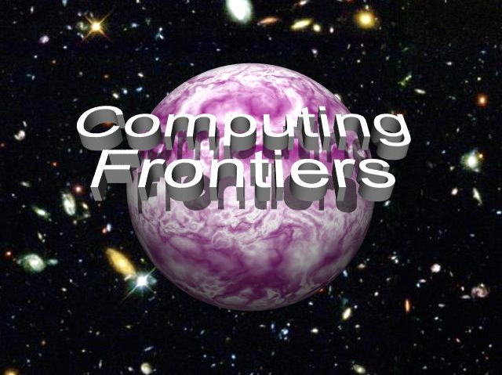

CALL FOR PAPERS
2010 ACM International Conference on Computing Frontiers

May 17 - 19, 2010, Bertinoro, Italy

Sponsored by ACM SIGMICRO



GENERAL CHAIR
Nancy M. Amato, Texas A&M University, US

PROGRAM CO-CHAIRS
Hubertus Franke, IBM Research, US
Paul H J Kelly, Imperial College London, UK

FINANCE/REGISTRATION CO-CHAIRS
Andreas Liehr, UniBw Munchen, DE
Carsten Trinitis, TU Munchen, DE

POSTERS CHAIR
Pedro Trancoso, University of Cyprus, CY

LOCAL ARRANGEMENTS CO-CHAIRS
Gianfranco Bilardi, University of Padova, IT
Luciano Margara, University of Bologna, IT

PUBLICITY CO-CHAIRS
Josef Weidendorfer, TU Munchen, DE
Jyh-Ming Lien, George Mason University, US

PUBLICATION CHAIR
Roberto Gioiosa, BSC, SP

WEB CHAIR
Alex Heinecke, TU Munchen, DE

STEERING COMMITTEE
Monica Alderighi, INAF, IT
Steven Beaty, Metro State College Denver, US
Gianfranco Bilardi, University of Padova, IT
Sergio D'Angelo, INAF, IT
Kemal Ebcioglu, Global Supercomputing, US
Georgi N. Gaydadjiev, TU Delft, NL
Michael Gschwind, IBM STG, US
Gearold Johnson, Colorado State U., US
Sally A. McKee, Chalmers U. of Tech., SW
Cecilia Metra, University of Bologna, IT
Alex Ramirez, UPC, ES
Valentina Salapura, IBM Research, US
Giacomo Sechi, INAF, IT
Carsten Trinitis, TU Munchen, DE
Alex Veidenbaum, University of California, US



The increasing complexity and performance needs of current and future applications require novel and innovative approaches for design of various types of computing systems: embedded, mobile, high-performance, and more. Boundaries between state of the art and revolutionary innovation constitute the computing frontiers that must be pushed forward to provide the computational support required for the advancement of science and engineering. This conference focuses on a wide spectrum of advanced technologies and radically new solutions relevant to development of computer systems and aims to foster communication among scientists and engineers to achieve this.
Authors are invited to submit full papers and poster papers on all areas of innovative computing systems that extend the current frontiers of computer science and engineering. Submissions are sought on innovations in theory, methodologies, technologies, and implementation of advanced computer systems and focusing on computing paradigms, computational models, application paradigms, computer architecture, development environments, compilers, and operating environments. Papers are solicited in, but not limited to, the following areas:
- Next-generation high performance computing and systems;
- Applications, programming models and performance analysis of advanced architectures;
- Accelerators: manycore, GPU, custom, reconfigurable, embedded, hybrid;
- Active libraries, domain-specific languages and generative techniques;
- Defect and variability-tolerant designs;
- Power and energy efficiency – in architectures, compilers and algorithms;
- Virtualization and virtual machines;
- Cloud-, internet-scale, service-oriented and smart infrastructure computing;
- Compilers and operating systems - adaptive, run-time and auto-tuning;
- System management and security;
- Quantum and nano-scale computing;
- Computational neuroscience, neuromorphic and biologically-inspired architectures;
- Novel frontiers in computational science and scientific data repositories;
- Computational aspects of intelligent systems and robotics;
- Reconfigurable, autonomic, organic and self-organizing computation and systems;
- Interfaces and visualization for emerging applications and systems: displays, VR, haptics.
Submissions must be made electronically in PDF format through the conference web site at http://www.computingfrontiers.org/2010. Submitted papers should not exceed 20 double-spaced, single-column pages, including figures, tables, and references. Poster papers are also invited, and should not exceed 4 double-spaced, single-column pages, including figures, tables, and references. Additional submission guidelines will be available on the conference web site.
Selected papers will be invited to appear in a special issue of the Springer International Journal of Parallel Programming (IJPP).
Important Dates

Abstract Deadline  December 4, 2009 | Paper Submission Deadline  December 11, 2009 | Author Notification  February 17, 2010

For more information visit the conference web site at http://www.computingfrontiers.org



