
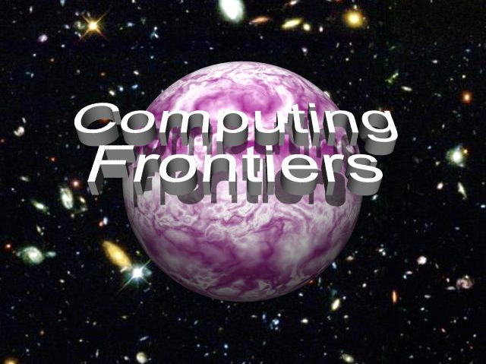

CALL FOR PAPERS
2009 ACM International Conference on Computing Frontiers

May 18 - 20, 2009, Ischia, Italy

Sponsored by ACM SIGMICRO



GENERAL CO-CHAIRS
Carsten Trinitis, TU München, DE
Gearold Johnson, Colorado State U., US

PROGRAM CO-CHAIRS
Alex Veidenbaum, UC Irvine, US
Georgi N Gaydadjiev TU Delft, NL

FINANCE/REGISTRATION CHAIR
Monica Alderighi, INAF, IT

SPECIAL SESSIONS CHAIR
Josef Weidendorfer, TU München, DE

LOCAL ARRANGEMENTS CHAIR
Claudia Di Napoli, CNR, IT

PUBLICITY CHAIR
Soner Onder, MTU, US

PUBLICATION CHAIR
Sergio D'Angelo, INAF, IT

WEB CHAIR
Andreas Liehr, Univ. Bundeswehr München, DE

STEERING COMMITTEE
Monica Alderighi, INAF, IT
Utpal Banerjee, Intel, US
Steven Beaty, Metro State College Denver, US
Gianfranco Bilardi, University of Padova, IT
Sergio D'Angelo, INAF, IT
Kemal Ebcioglu, Global Supercomputing, US
Michael Gschwind, IBM TJ Watson, US
Gearold Johnson, Colorado State U., US
Sally A. McKee, Chalmers U. of Tech., SW
Cecilia Metra, University of Bologna, IT
José Moreira, IBM TJ Watson, US
Alex Ramirez, UPC, ES
Giacomo Sechi, INAF, IT


The increasing complexity and performance needs of current and future applications require novel and innovative approaches for design of various types of computing systems: embedded, mobile, high-performance, and more. Boundaries between state of the art and revolutionary innovation constitute the computing frontiers that must be pushed forward to provide the computational support required for the advancement of science and engineering. This conference focuses on a wide spectrum of advanced technologies and radically new solutions relevant to development of computer systems and aims to foster communication among scientists and engineers to achieve this.
Authors are invited to submit papers on all areas of innovative computing systems that extend the current frontiers of computer science and engineering. Papers are sought on innovations in theory, methodologies, technologies, and implementation of advanced computer systems and focusing on computing paradigms, computational models, application paradigms, computer architecture, development environments, compilers, and operating environments. Papers are solicited in, but not limited to, the following areas:
- Non-conventional computing;
- Next-generation high performance computing and systems;
- Application specific acceleration: Cell, GPGPU, custom and reconfigurable;
- Applications, programming models and performance analysis of advanced architectures;
- Virtualization and virtual machines;
- Grid computing;
- Compilers and operating systems;
- Workload characterization of emerging applications;
- Service oriented architecture (SOA) and system impact;
- Supercomputing;
- SOC architectures, embedded systems and special-purpose architectures;
- Temperature, energy, and variability-aware designs;
- Fault tolerance and reliability at all levels of the system;
- System management and security;
- Quantum and nano-scale computing;
- Computational biology;
- Reconfigurable computing and architecture prototyping;
- Autonomic and organic computing;
- Computation intelligence frontiers: theory and industrial applications.
Submissions must be made electronically in PDF format through the conference web site at http://pcsostres.ac.upc.edu/cf09/ . Submitted papers should not exceed 20 double-spaced, single-column pages, including figures, tables, and references. Additional submission guidelines will be available on the conference web site.
Authors of accepted papers are expected to attend the conference and present the paper. Selected papers will be invited to appear in a special issue of (Springer) Intl. Journal of Parallel Programming and/or Transactions on HiPEAC (pending).

Important Dates

Abstract Deadline  December 5, 2008 | Paper Submission Deadline  December 12, 2008 | Author Notification  February 18, 2009

For more information visit the conference web site at http://www.computingfrontiers.org

