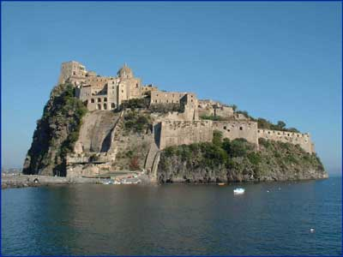
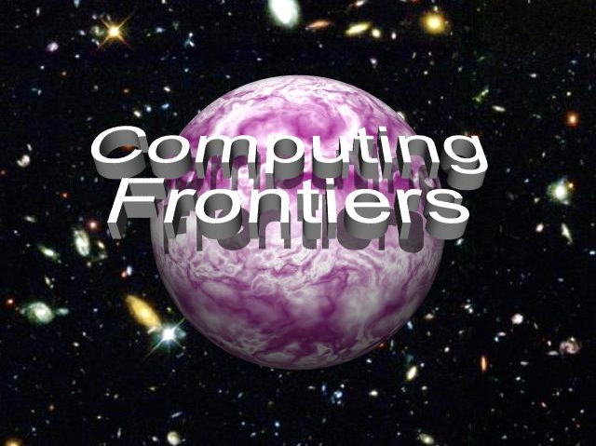

CALL FOR PARTICIPATION
2008 ACM International Conference on Computing Frontiers

The increasing needs of present and future computation-intensive applications have stimulated research in new and innovative approaches to the design and implementation of high-performance computing systems. These challenging boundaries between state of the art and innovation constitute the computing frontiers, which must push forward and provide the computational support required for the advancement of all science domains and applications. This conference focuses on a wide spectrum of advanced technologies and radically new solutions, and is designed to foster communication between the various scientific areas and disciplines involved.
The technical program will include 3 keynote talks, a poster session on innovative computing and technical sessions covering all areas of innovative computing systems that extend the current frontiers of computer science and engineering and that will provide advanced systems for current and future applications. The conference also includes two workshops and a special session on FP7 Computing Systems Projects.
Keynote Talks
Keshav Pingali, UT Austin, Data-parallel Abstractions for Irregular Programs
Valentina Salapura, IBM Watson, Scaling Up Next Generation Supercomputers
Raffaele Tripiccione, U Ferrara, JANUS: Reconfigurable High-Performance Computing for Physics
Technical Sessions
- Innovative Computing Platforms (Cell, GPGPU, FPGAs)
- Programming Models
- High-Performance Computing
- Microarchitecture for Low Power, High Reliability and New Application Domains
- Innovative Design
- Innovative Compilation Techniques
- Innovative Systems
- Poster Session
Workshops and Special Session
Workshop on “Memory Access on Future Processors: A Solved Problem?”
Workshop on “Radiation Effects and Fault Tolerance in Nanometer Technologies”

A Special Session on the European Union’s Seventh Framework FP7 Computing Systems Projects will allow researchers to present and discuss their research results at Computing Frontiers 2008.
Important Dates
Early registration deadline: April 4, 2008
Conference hotel rate available until April 18, 2008

For more information visit the conference web site at http://www.computingfrontiers.org


GENERAL CHAIR
Alex Ramirez, UPC

PROGRAM CO-CHAIRS
Gianfranco Bilardi, Università di Padova
Michael Gschwind, IBM TJ Watson

PROGRAM COMMITTEE
David Brooks, Harvard U.
Barbara Chapman, Houston U.
Fred Chong, UC Santa Barbara
Matteo Frigo, Cilk Arts
Guang R. Gao, U. Delaware
Kieran Herley, U. College Cork
Philippe Jorrand, CNRS
Ben Juurlink, TU Delft
Dave Kaeli, Northeastern U.
Alvin Lebeck, Duke U.
Hsien-Hsin Lee, Georgia Tech
Wei Li, Intel
Gabriel Loh, Georgia Tech
Sally McKee, Cornell U.
Bilha Mendelson, IBM Haifa Lab
Hiroshi Nakamura, U. Tokyo
Keshav Pingali, UT Austin
Victor Prasanna, USC
Geppino Pucci, U. Padova
Markus Pueschel, CMU
Larry Rudolph, MIT
Uli Ruede, U. Erlangen
Fabio Schifano, U. Ferrara
André Seznec, IRISA/INRIA
Gabriel Silberman, CA Labs
Dan Sorin, Duke
Michela Taufer, U. Delaware
Eli Upfal, Brown U.
Alex Veidenbaum, UC Irvine

FINANCE CHAIR
Carsten Trinitis, TU München

SPECIAL SESSIONS CHAIR
Osman Unsal, BSC

LOCAL ARRANGEMENTS CHAIR
Claudia Di Napoli, CNR

PUBLICITY CHAIR
Julita Corbalan, UPC

LIAISON CHAIR FOR ASIA
Hitoshi Oi, U. Aizu

REGISTRATION CHAIR
Monica Alderighi, INAF

PUBLICATION CHAIR
Sergio D'Angelo, INAF

WORKSHOPS AND WEB CHAIR
Greg Bronevetsky, LLNL

May 5 - 7, 2008, Ischia, Italy

Sponsored by ACM - SIGMICRO

