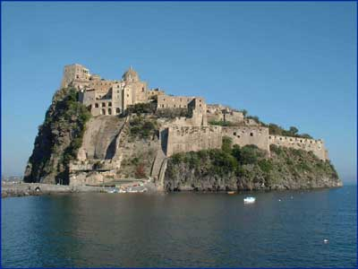
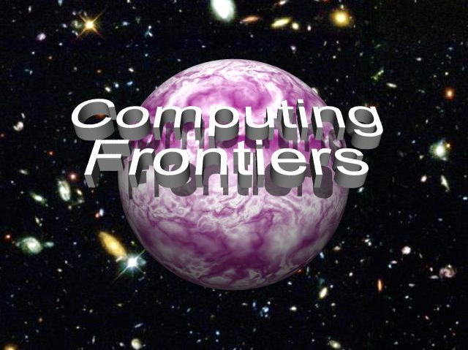

CALL FOR PARTICIPATION
2008 ACM International Conference on Computing Frontiers

The increasing needs of present and future computation-intensive applications have stimulated research in new and innovative approaches to the design and implementation of high-performance computing systems. These challenging boundaries between state of the art and innovation constitute the computing frontiers, which must push forward and provide the computational support required for the advancement of all science domains and applications. This conference focuses on a wide spectrum of advanced technologies and radically new solutions, and is designed to foster communication between the various scientific areas and disciplines involved.
The conference program includes papers on all areas of innovative computing systems that extend the current frontiers of computer science and engineering and that will provide advanced systems for current and future applications:
- Non-conventional computing
- Next-generation high performance computing, esp. novel high-performance systems (including Cell, GPGPU and custom accelerators)
- Applications, programming models and performance analysis of parallel architectures and novel high-performance systems
- Virtualization and virtual machines
- Grid computing
- Compilers and operating systems
- Workload characterization of emerging applications
- Service oriented architecture (SOA) and system impact
- Supercomputing
- SOC architectures, embedded systems and special-purpose architectures
- Temperature, energy, and variability-aware designs
- Fault tolerance and reliability
- System management and security
- Quantum and nanoscale computing
- Computational biology
- Reconfigurable computing and architecture prototyping
- Autonomic and organic computing
- Computation intelligence frontiers: theory and industrial applications

Workshops
Workshop on “Memory Access on Future Processors: A Solved Problem?”

Workshop on “Radiation Effects and Fault Tolerance in Nanometer Technologies”

Important Dates

Early registration deadline: April 4, 2008
Conference hotel rate available until April 18, 2008

For more information visit the conference web site at http://www.computingfrontiers.org


GENERAL CHAIR
Alex Ramirez, UPC

PROGRAM CO-CHAIRS
Gianfranco Bilardi, Università di Padova
Michael Gschwind, IBM TJ Watson

PROGRAM COMMITTEE
David Brooks, Harvard U.
Barbara Chapman, Houston U.
Fred Chong, UC Santa Barbara
Matteo Frigo, Cilk Arts
Guang R. Gao, U. Delaware
Kieran Herley, U. College Cork
Philippe Jorrand, CNRS
Ben Juurlink, TU Delft
Dave Kaeli, Northeastern U.
Alvin Lebeck, Duke U.
Hsien-Hsin Lee, Georgia Tech
Wei Li, Intel
Gabriel Loh, Georgia Tech
Sally McKee, Cornell U.
Bilha Mendelson, IBM Haifa Lab
Hiroshi Nakamura, U. Tokyo
Keshav Pingali, UT Austin
Victor Prasanna, USC
Geppino Pucci, U. Padova
Markus Pueschel, CMU
Larry Rudolph, MIT
Uli Ruede, U. Erlangen
Fabio Schifano, U. Ferrara
André Seznec, IRISA/INRIA
Gabriel Silberman, CA Labs
Dan Sorin, Duke
Michela Taufer, U. Delaware
Eli Upfal, Brown U.
Alex Veidenbaum, UC Irvine

FINANCE CHAIR
Carsten Trinitis, TU München

SPECIAL SESSIONS CHAIR
Osman Unsal, BSC

LOCAL ARRANGEMENTS CHAIR
Claudia Di Napoli, CNR

PUBLICITY CHAIR
Julita Corbalan, UPC

LIAISON CHAIR FOR ASIA
Hitoshi Oi, U. Aizu

REGISTRATION CHAIR
Monica Alderighi, INAF

PUBLICATION CHAIR
Sergio D'Angelo, INAF

WEB CHAIR
Greg Bronevetsky, LLNL

May 5 - 7, 2008, Ischia, Italy

Sponsored by ACM - SIGMICRO

