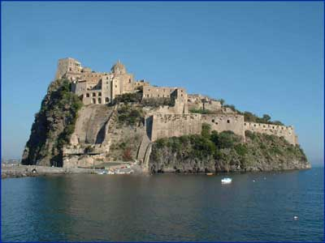
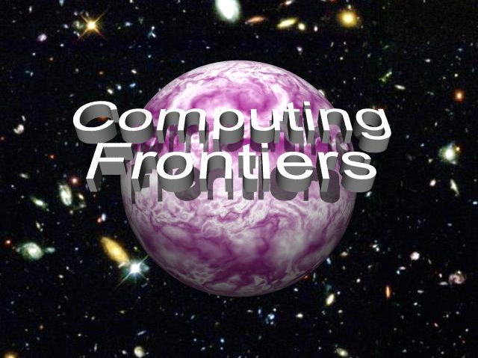
The increasing needs of present and future computation-intensive applications have stimulated research in new and innovative approaches to the design and implementation of high-performance computing systems. These challenging boundaries between state of the art and innovation constitute the computing frontiers, which must push forward and provide the computational support required for the advancement of all science domains and applications. This conference focuses on a wide spectrum of advanced technologies and radically new solutions, and is designed to foster communication between the various scientific areas and disciplines involved.
Authors are invited to submit papers on all areas of innovative computing systems that extend the current frontiers of computer science and engineering and that will provide advanced systems for current and future applications. Papers are sought on theory, methodologies, technologies, and implementations concerned with innovations in computing paradigms, computational models, architectural paradigms, computer architectures, development environments, compilers, and operating environments. Papers should be submitted to one of the following areas:

- Non-conventional computing  - Next generation high performance computing  - Grid computing  - Reconfigurable computing  - Special purpose architectures  - Compilers and operating systems  - Supercomputing  - SOC architectures  - High performance embedded architectures  - Pervasive computing | - Temperature, energy, and complexity-aware designs  - Quantum computing  - Autonomic and organic computing  - Architectures and devices for emerging nanotechnologies  - Workload characterization of emerging applications  - Computations intelligence frontiers: theory and industrial applications  - Computational biology  - System management and security  - Open topics
Selected papers will be published in special issues of the ACM Journal of Emerging Technology in Computing Systems or the Journal of Instruction Level Parallelism. Submitted manuscripts should not exceed 20 double-spaced single-column pages, including figures, tables, and references. Submission implies that at least one author will register for the conference and present the paper. Submissions must be made electronically as Adobe PDF files through the conference website.

Important Dates
Abstract submission deadline: December 9, 2005
Full paper submission deadline: December 16, 2005
Author notification: January 24, 2006
Full paper submission deadline: February 24, 2006

CALL FOR PAPERS
2006 ACM International Conference on Computing Frontiers

May 2-5, 2006, Ischia, Italy

Sponsored by ACM - SIGMICRO


GENERAL CO-CHAIRS
Monica Alderighi, INAF– IASF, IT
monica@mi.iasf.cnr.it
Valentina Salapura, IBM, US
salapura@us.ibm.com

PROGRAM CHAIR
Sally A. McKee, Cornell University, US
sam@csl.cornell.edu

STEERING COMMITTEE
Monica Alderighi, INAF– IASF, IT
Steven Beaty, Metro State College of Denver, US
Nader Bagherzadeh, UCI, US
Sergio D'Angelo, INAF– IASF, IT
Kemal Ebcioglu, IBM, US
Jean-Luc Gaudiot, UCI, US
Gearold Johnson, Colorado State University, US
Sally A. McKee, Cornell University, US
Cecilia Metra, University of Bologna, IT
Alex Ramirez, UPC, ES
Vincenzo Piuri, Politecnico Milano, IT
Giacomo Sechi, INAF– IASF, IT
Mateo Valero, UPC, ES
Stamatis Vassiliadis, TU Delft, NL

PROGRAM COMMITTEE
Rich Belgard, Consultant
Utpal Banerjee, Intel, US
Luca Benini, University of Bologna, IT
Mainak Chaudhuri, IIT Kanpur, IN
Lieven Eeckhout, Universiteit Gent, BE
John Feo, Cray, US
Pierfrancesco Foglia, University of Pisa, IT
Gearold Johnson, Colorado State University, US
Ben Juurlink, TU Delft, NL
Achilles Kameas, CTI, GR
Prabhakar Kudva, IBM, US
Kai Li, Princeton, US
Gabriel Loh, Georgia Institute of Technology, US
Bilha Mendelson, IBM, IL
Jose Moreira, IBM, US
Alex Nicolau, University of California at Irvine, US
Matteo Paris, University of Milan, IT
Vincenzo Piuri, University of Milan, IT
Antonio Prete, University of Pisa, IT
Lucian Prodan, University of Timisoara, RO
Lawrence Rauchwerger, Texas A&M, US
Gabby Silberman, CA Labs, US
Jordi Torres, UPC, ES
Theo Ungerer, University of Augsburg, DE
Mateo Valero, UPC, ES
Stamatis Vassiliadis, TU Delft, NL
Alex Veidenbaum, University of California-Irvine, US
Patrick Widener, University of New Mexico, US

SPECIAL SESSIONS CHAIR
Giacomo Sechi, INAF– IASF, IT
giacomo@mi.iasf.cnr.it

LOCAL ARRANGEMENTS CHAIR
Claudia Calidonna, CNR, IT
C.Calidonna@cib.na.cnr.it

PUBLICITY CHAIR
Jordi Torres, UPC, ES
torres@ac.upc.edu

FINANCE/REGISTRATION CHAIR
Carsten Trinitis, TUM, DE
Carsten.Trinitis@in.tum.de
For more information, visit the conference web site at http://www.computingfrontiers.org

