  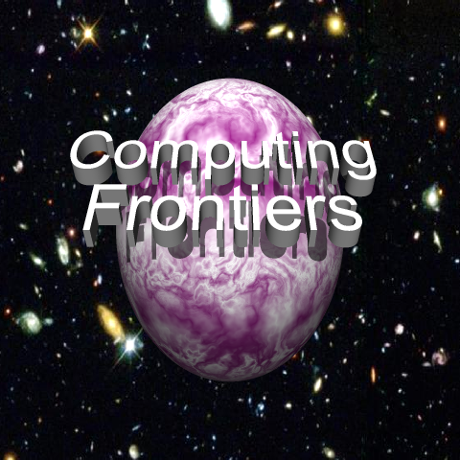 | CF ’04  2004 ACM International Conference on  Computing Frontiers  Ischia, Italy, 14-16 April 2004  Sponsored by ACM – SIGMICRO

General Chair
Stamatis Vassiliadis, Delft University of Technology, NL
Technical Program Chairs
Jean-Luc Gaudiot, University of California at Irvine, US
Vincenzo Piuri, University of Milan, IT
Program Committee
Nader Bagherzadeh, University of California at Irvine, US
Charlie Catlett, Argonne National Laboratory, US
Toni Cortes, Universitat Politècnica de Catalunya, ES
Renzo Davoli, University of Bologna, IT
Kemal Ebcioğlu, IBM, US
Paolo Faraboschi, Hewlett-Packard, ES
Edil S.T. Fernandes, Universidad Federal de Rio de Janeiro, BR
David Fogel, Natural Selection Inc., US
Guang R. Gao, University of Delaware, US
Iliya Georgiev, Metro State College of Denver, US
Michael E. Hasselmo, Boston University, US
Lakhmi C. Jain, University of South Australia, AU
Simon Jones, University of Bath, UK
Fabrizio Lombardi, Northeastern University, US
Miroslaw Malek, Humboldt-Universität zu Berlin, DE
Cecilia Metra, University of Bologna, IT
Gábor Németh, Technical University of Budapest, HU
Yale Patt, University of Texas at Austin, US
Alex Pentland, MIT, US
Emil Petriu, University of Ottawa, CA
Martin B Plenio, Imperial College, UK
Kaushik Roy, Purdue University, US
Grzegorz Rozenberg, Leiden University, NL
Norbert Streitz, Fraunhofer IPSI, DE
Bogong Su, William Paterson University of New Jersey, US
Earl E. Swartzlander, University of Texas at Austin, US
John Taylor, Quadrics Supercomputers Ltd, UK
Alex Yakovlev, University of Newcastle upon Tyne, UK
Special Sessions Chair
Giacomo Sechi, CNR - Istituto di Astrofisica Spaziale e Fisica Cosmica, IT
PublicityChair
Steven Beaty, Metro State College of Denver, US
Publication Chair
Monica Alderighi, CNR - Istituto di Astrofisica Spaziale e Fisica Cosmica, IT
Local Arrangements Chair
Sergio D’Angelo, CNR - Istituto di Astrofisica Spaziale e Fisica Cosmica, IT
Treasurer
Steven Beaty, Metro State College of Denver, US
Steering Committee
Monica Alderighi, CNR - Istituto di Astrofisica Spaziale e Fisica Cosmica, IT
Steven Beaty, Metro State College of Denver, US
Sergio D’Angelo, CNR - Istituto di Astrofisica Spaziale e Fisica Cosmica, IT
Kemal Ebcioğlu, IBM, US
Cecilia Metra, University of Bologna, IT
Gearold Johnson, Colorado State University, US
Nello Scarabottolo, University of Milan, IT
Giacomo Sechi, CNR - Istituto di Astrofisica Spaziale e Fisica Cosmica, IT

Web Site: http://www.computingfrontiers.org
The increasing needs of present and future computation-intensive applications have stimulated research in new and innovative approaches to the design and implementation of high-performance computing systems. This challenging boundary between state of the art and innovation constitutes the computing frontiers, which needs to push forward and provide the computational support required for the advancement of all science domains and applications. This conference will focus on a wide spectrum of advanced technologies and radically new solutions and is designed to foster communication between the various scientific areas and disciplines involved.
Authors are invited to submit papers on all areas of innovative computing systems which extend the current frontiers of computer science and engineering and that will provide advanced systems for current and future applications.
Papers are sought on theory, methodologies, technologies, and implementations concerned with innovations in computing paradigms, computational models, architectural paradigms, computer architectures, development environments, compilers, operating environments, etc. Main topics include, but are not limited to, the following.
- Pervasive and ubiquitous computing  - Embedded processing and networking  - Wearable computing  - Systems and networks on chip  - Grid computing  - Parallel computing systems  - Clustered computing systems and server farms  - High-performance processors  - Application-specific computing systems  - High-performance parallel storage and I/O systems  - High-performance networked storage systems | - Resilient and dependable computing systems  - Autonomous intelligent computing systems  - Nanotechnologies for high-performance computing  - Quantum computing  - Molecular computing  - Computational neuroscience  - Neuromorphic computing  - Evolutionary systems  - Computing systems for bioinformatics  - Computing systems for knowledge processing  - Computing systems for virtual environments
PAPER SUBMISSION DEADLINE: NOVEMBER 15, 2003
Submission details and all information concerning the symposium can be found at the conference web site (http://www.computingfrontiers.org).
Acceptance/rejection will be emailed by December 20, 2003. The final manuscript will due January 24, 2004. Submission implies that at least one author will register at the conference and present the paper.

